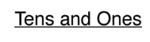
Write the correct number of tens and ones.
